|  |  |
| --- | --- |
| **Subject** | SWA – CS590 |
| **Assignment** | Lab 9 |
| **Date** | 8/28/2021 |
| **Students** | Vo Ngoc Huy Nguyen - 611066 |
| **Professor** | Rene de Jong |

# Lab Assignment 9: Microservice

**Exercise 1: Service registry with Eureka**

* Config and start EurekaServer

* Config and start Account Client and Customer Client

Call GET to test

Refer attached source codes for more details

**Exercise 2: Using Ribbon**

Project as below:

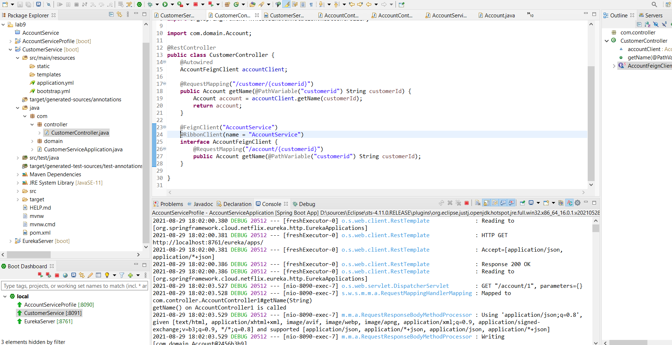

**Exercise 3: Apply to WebShop**

